**Azure regions**

Azure is generally available in 36 regions around the world, with plans announced for 6 additional regions. We place a high priority on geographic expansion to enable higher performance, and to support your requirements and preferences regarding data location.

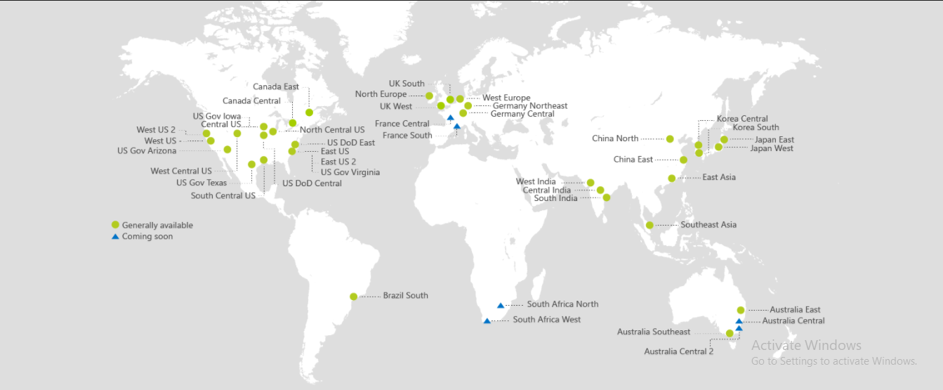

**Locations**

[Americas](https://azure.microsoft.com/en-us/regions/services/?zone=americas)

|  |  |
| --- | --- |
| Region | Location |
| East US | Virginia |
| East US 2 | Virginia |
| Central US | Iowa |
| North Central US | Illinois |
| South Central US | Texas |
| West Central US | West Central US |
| West US | California |
| West US 2 | West US 2 |
| US Gov Virginia | Virginia |
| US Gov Iowa | Iowa |
| US DoD East | Virginia |
| US DoD Central | Iowa |
| US Gov Arizona | Arizona |
| US Gov Texas | Texas |
| Canada East | Quebec City |
| Canada Central | Toronto |
| Brazil South | Sao Paulo State |

[Europe](https://azure.microsoft.com/en-us/regions/services/?zone=europe)

|  |  |
| --- | --- |
| Region | Location |
| North Europe | Ireland |
| West Europe | Netherlands |
| UK West | Cardiff |
| UK South | London |
| Germany Central | Frankfurt |
| Germany Northeast | Magdeburg |

|  |  |
| --- | --- |
| Newly announced | |
| France Central | Paris |
| France South | Marseille |

[Asia Pacific](https://azure.microsoft.com/en-us/regions/services/?zone=asia)

|  |  |
| --- | --- |
| Region | Location |
| Southeast Asia | Singapore |
| East Asia | Hong Kong |
| Australia East | New South Wales |
| Australia Southeast | Victoria |
| China East | Shanghai |
| China North | Beijing |
| Central India | Pune |
| West India | Mumbai |
| South India | Chennai |
| Japan East | Tokyo, Saitama |
| Japan West | Osaka |
| Korea Central | Seoul |
| Korea South | Busan |

| **Newly announced** | |
| --- | --- |
| Australia Central 1 | Canberra |
| Australia Central 2 | Canberra |

[Africa](https://azure.microsoft.com/en-us/regions/services/?zone=africa)

|  |  |
| --- | --- |
| Region | Location |

|  |  |
| --- | --- |
| Newly announced | |
| South Africa West | Cape Town |
| South Africa North | Johannesburg |